**Aim -**

Advanced

HTML5 tags (div,span,frame,form etc).

New tags in HTML5(semantic tag,multimedia tag(audio,video,embed,SVG,form elements

etc.)

Programs:

(a) Design the VESIT website home page using advanced tags of HMTL5 (frame, div, semantic tags, multimedia tags, etc.)

Or

Design News Portal website home page using advanced tags of HMTL5 (frame, div, semantic tags, multimedia tags, etc.)

(b) Design FE admission form using HTML5 form tags.

(Note: use New form Input type and attributes introduced in HTML5)

**Theory-**

The <input> HTML element is used to create interactive controls for web-based forms to accept data from the user; a wide variety of input data and control widgets are available, depending on the device and user agent. The <input> element is one of the most powerful and complex in all HTML due to the sheer number of combinations of input types and attributes.

The <audio> HTML element is used to embed sound content in documents. It may contain one or more audio sources, represented using the src attribute or the <source> element: the browser will choose the most suitable one. It can also be the destination for streamed media, using MediaStream.

The <video> HTML element embeds a media player which supports video playback into the document. You can also use <video> for audio content, but the <audio> element may provide a more appropriate user experience.

**Screenshots-**

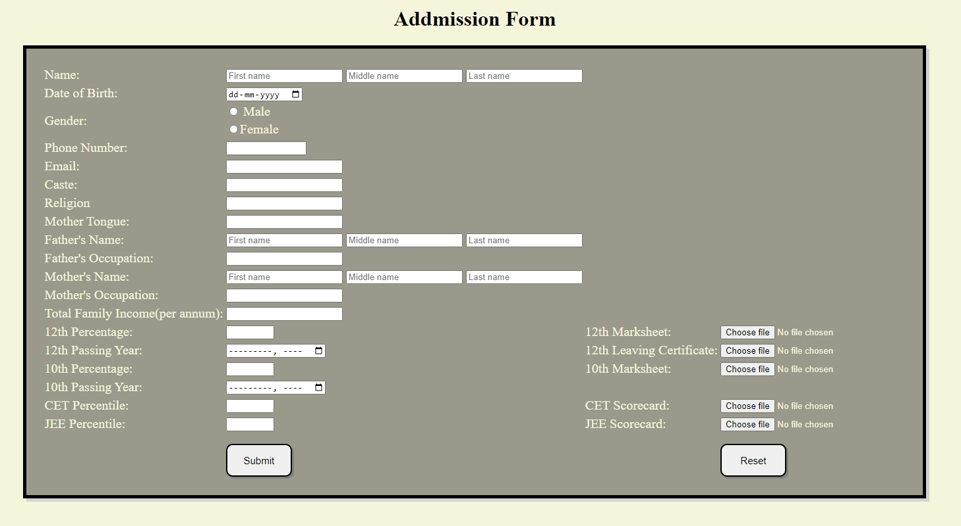

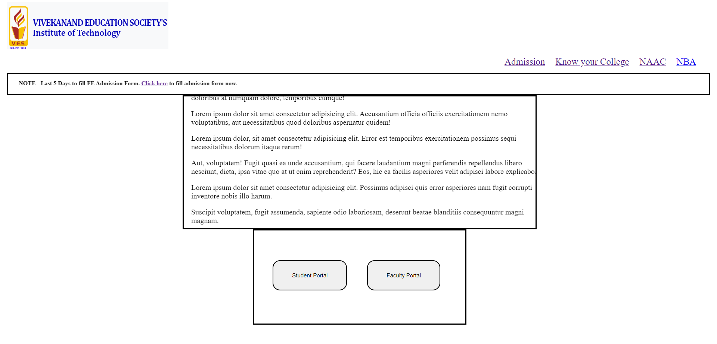

**Conclusion-**

We have successfully created VESIT website and admission form for FE.